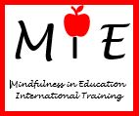
MINDFULNESS IN EDUCATION

ISABELLE MARIE ZAMMIT
Year 1, Rabat Primary (Happy) School, Gozo

has been awarded this certificate for
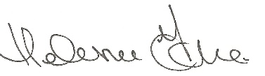
learning how to be Mindful.
15th December 2017
Helena Fone
www.mindfulnessineducation.com

